Practice Assignment – C#

Day 1

Problem Description 1: Accept the temperature from the user. If the temperature is less than or equal to 32, display a message “The climate is good today” and check whether the temperature is exactly equal to 32. If it is exactly equal to 32, display a message “The temperature is 32”. If the temperature is greater than 32, then display a message “It is hot today”.

Problem Description 2: Write a program “StringManipulation.cs” in C# which accepts two strings. The program should do the following:

- print and display the total number of occurrences of the character „a‟ or „A‟ present in both the strings

- replace every occurrence of ‘a’ or ‘A’ with @

- convert both the strings to upper case

- concatenate the two strings and display the result

- declare one variable of type StringBuilder and perform operations like Append(), Insert(), Remove(), Replace().

Perform i, ii, iii, iv on String variable.

Problem Description 3: Create a login screen that accepts login name and password. Allow the user a maximum of 3 chances only. In case the user is unsuccessful in logging in after three attempts, exit the application. Display message “Welcome to C# Applications” when the Login ID is “BootCamp” and password is “hpel”. Otherwise display the message “Invalid login”.

Problem Description 4: Create a class with a data member. Assign a value to the data member and display it.

Define a new class called, ‘Building’ with a public integer data member called ‘Area’,

- Within Main, Create an object of class ‘Building’ called ‘house’ and print the area of the house.

- Add two integer data members ‘occupants’ and ‘floors’ within the ‘Building’.

- In Main method, create one more object of class ‘Building’ called ‘office’.

- Assign the values of data members to house and office object.

- Calculate ‘areaPerPerson’ using the formula as given below areaperPerson = house.area/house.occupants;

- Similarly calculate the areaPerPerson for office.

- Display areaPerPerson for both the objects as follows:
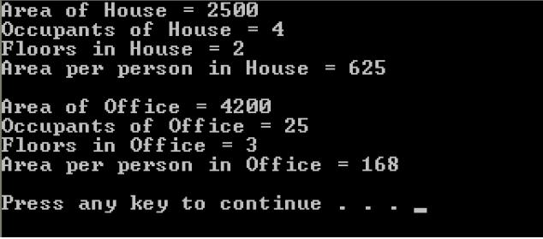

- Make changes in class to Add a method named AreaPerPerson to calculate area required per person within ‘Building’ class.

- Call the method AreaPerPerson for both objects and display the return value.

Problem Description 4: To define and use a method with ref, out, params parameters within a class.

Create a new console application and name it as ‘ParametersDemo’. Create a new class within the namespace called ‘Calculator’ having a method called ‘AddAndSubtract’ to perform the operations on two integer inputs and assign their sum and difference to two ‘out’ parameters..

Problem Description 5: Create a console application to print a message with default value. Add the ‘readonly’ attribute to default message specified in the class to prevent it from being reassigned.

Problem Description 6: Create a simple Console Application and add a class “BankAccount” which takes accountNumber as int, accountHolderName as string and Balance as double. Add a Display Method to display the account details.

Now create a separate method AccountTrans() method and Pass the BankAccount object to it a. by value and try updating the balance and then try changing the values of object passes

b. pass the BankAccount object by ref ; try updating the balance and then try changing the values of object passes

Call both the methods in main class and display the difference in output(if any).

